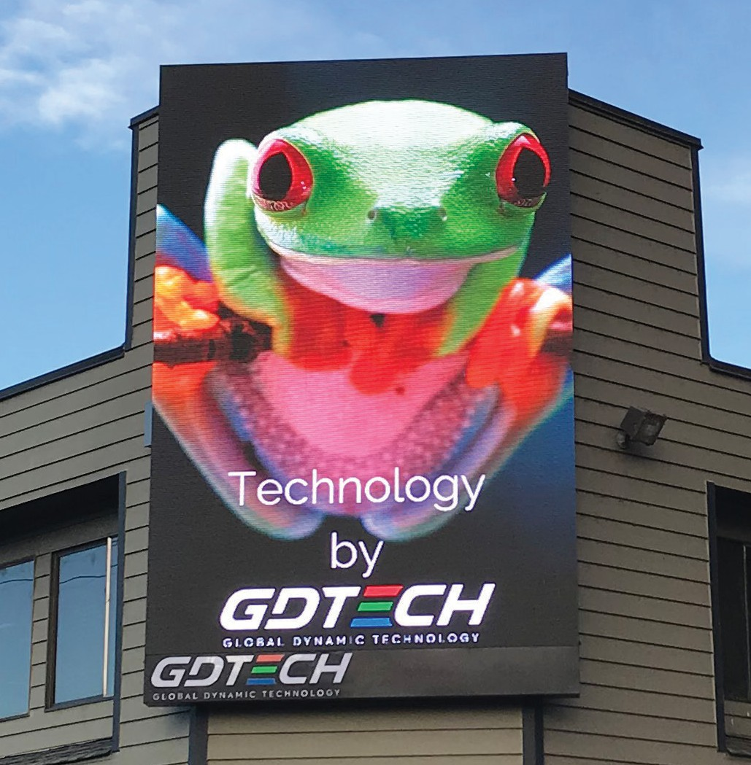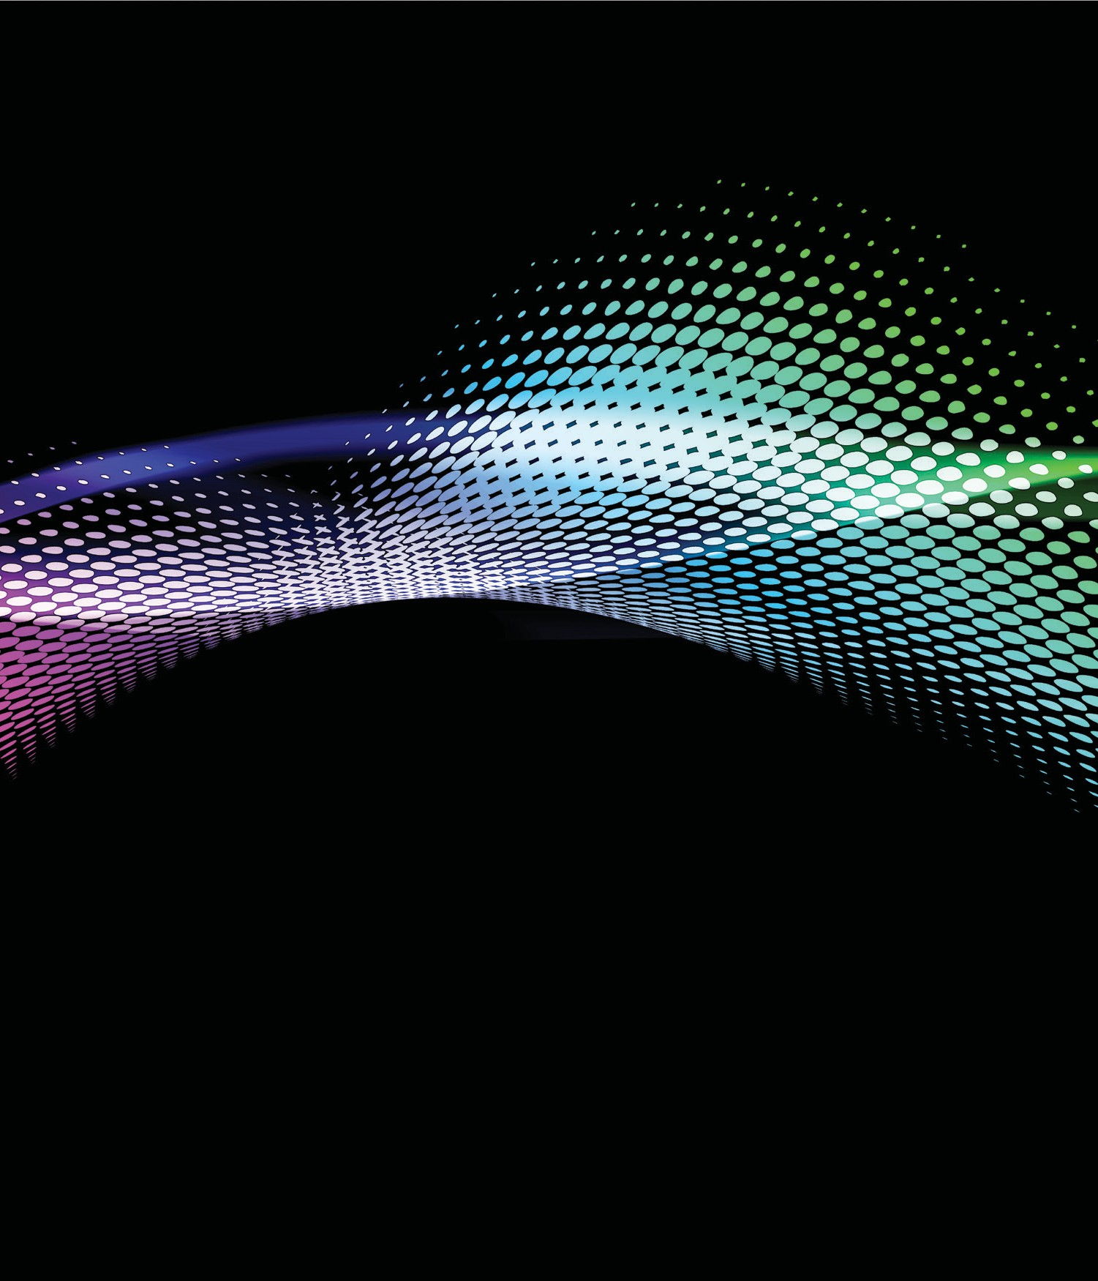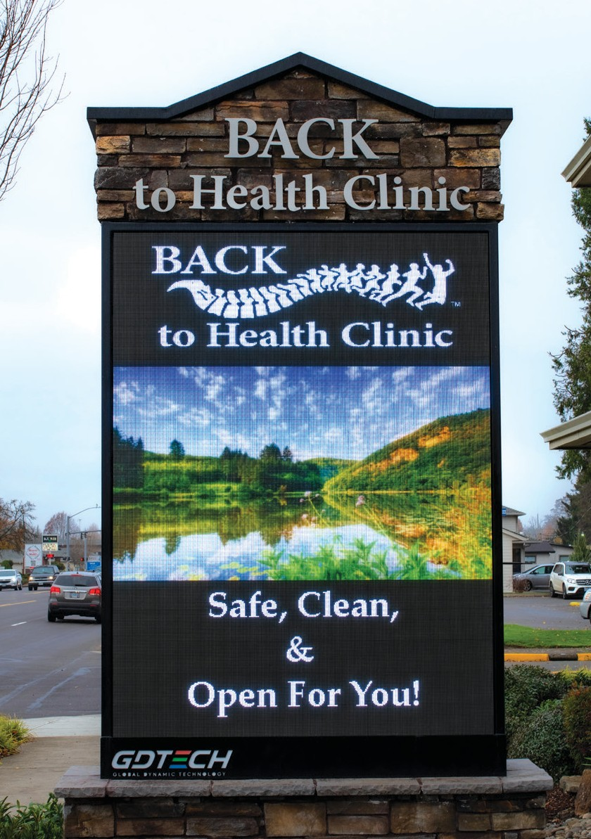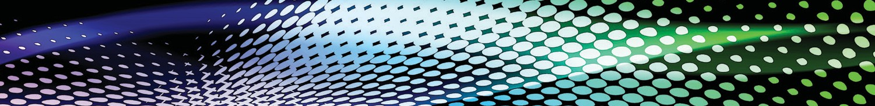
CLIENT NAME
loca
gone above and beyond making sure all
of those hurdles were met and overcome. GDTECH was able to go to them and show how being where I wanted it to be closer to the sidewalk was an acceptable location that didn’t meet the codes. GD-
“
With this being a relatively new
tion and obstacles that were presented to us with the city. GDTECH has really

TECH went above and beyond to make sure that they were able to meet my desire of where I wanted the sign and they made it happen.
Dr. Baker, ”owner BACK To Health Clinic Keizer, OR
WARRANTY PROGRAM

Global Dynamic Technology LLC warrants your new LED Sign (MLS) to be free from defects in factory materials and workmanship. Products believed to be a manufacturing defect will be repaired or replaced upon investigation of the issue. Global Dynamic Technology’s Class 5 Year Limited Warranty coverage***
HIGH RESOLUTION LED SIGNS

Defective parts are covered for 5 year from ship date / warranty activation **
- Electronic controller circuit boards
- LED panel assemblies *
- Power supplies, and auto dimmer
- Embedded Wi-Fi communication devices
- Wires,plugs, and ribbon cables.
- Embedded Wi-Fi
- 4G communication Devices

In-Factory Labor is covered for 5 years from ship date/warranty activation **
- Labor costs for repairing parts or complete products in Global Dynamic Technology’s factory location.

Exceptions:
* Less than 2% of dead LED lamps is considered acceptable and is not covered under warranty **Shipping both ways not covered
*** Does not include labor or travel for maintenance of the physical sign; only parts and components.

Global Dynamic Technology will provide quick service for replacing key parts in need of replacement. If a MLS product requires a replacement part or parts, Global Dynamic Technology will send
the customer the replacement part(s) once a credit card number is provided for security. Then the customer shall send the defective part(s) back to Global Dynamic Technology within 15 days or the customer’s card will be charged for the full value of the replacement part(s). This service allows the customer to get the sign back in working condition quickly and decreases display downtime.

Warranty and Limitation of Liability
This warranty shall not apply to any product for improper installation, unauthorized vandalism, destruction, loss, theft, negligence, damage or misuse of product. Nor does this warranty cover any malfunction or damage due to natural disasters or extraordinary weather conditions, such as, but not limited to: hurricane, typhoon, tsunami, earthquake or severe weather.
|
BOLDER BETTER
|
BRIGHTER
* Global Dynamic Technology reserves all the rights to modify or change this warranty without notice at anytime.
ACCOUNT EXECUTIVE: GREGG WALTERS
C: 503.728.6641 GREGG@GDTECHUSA.COM 1855 HAWTHORNE AVENUE NE, SALEM OR 97301

GLOBAL DYNAMIC TECHNOLOGY MAKES NO OTHER WARRANTIES WITH RESPECT TO THE PRODUCTS OR ANY SERVICES AND DISCLAIMS ALL IMPLIED WARRANTIES, INCLUDING WARRANTIES OF MERCHANTABILITY, NON- INFRINGEMENT AND FITNESS FOR A PARTICULAR PURPOSE, OR ARISING FROM A COURSE OF DEALING, USAGE OR TRADE PRACTICE.
|
WWW.GDTECH.COM 503.400.5607

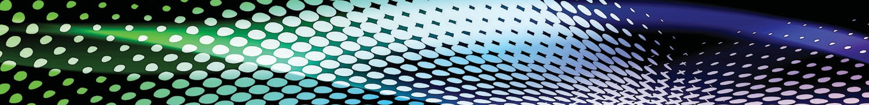
MEDIA ESTIMATE
OUR PATENTED SYSTEM | OUR ANNUAL ATTENUATION RATE IS 3%. THIS MEANS THAT OUR BULBS BRIGHTNESS AND VIVIDNESS OF COLOR LAST LONGER THAN OTHERS IN THE INDUSTRY WITH AN AVERAGE OF 15%.  OUR BULBS ANNUAL ATTENUATION RATE IS 500% BETTER THAN THE INDUSTRY.  ACCOUNT EXECUTIVE: GREGG WALTERS C: 503.728.6641  GREGG@GDTECHUSA.COM 1855 HAWTHORNE AVENUE NE, SALEM OR 97301  WWW.GDTECH.COM 503.400.5607
Patented Round SMD Bulbs
Oxygen Free Encapsulation, Smaller Lamp Dimension, No Reflection –
Encapsulation, High Efficiency Lighting, Three Colors (RGB) In Each Lamp
that creates our round SMD pixels.
Most of our competition use square pixels in their bulbs that decrease the readability through light distortion.
Gold Wire in Bulbs
Gold is the best metal for faster connectivity. Gold also reduces energy costs
and makes our bulbs brighter and much more efficient.
Most of our competition use stainless-steel or copper wires that can corrode and are not as energy efficient as gold wires.
Aluminum Modules
Our modules are built of extremely durable aluminum (the same type aluminum NASA used on the Space Shuttle) Not susceptible to UV Rays, heat, water, and weather. Solid state aluminum modules can battle the salt, corrosion, rain
and wind.
Our competitors use plastic modules with silicone that warp in the heat of the sun and degenerate from the heat of using LEDs and in hot weather.
Ultra Fast IC Drivers & PCB Boards
You need a fast IC Driver to show beautiful photos and videos. GDTECH
uses Ultra Fast IC Drivers that have a refresh rate of 3840 Hz.
We also use advanced PCB Boards that speed the flow of energy throughout the entire module and complete sign.
Fused & Sealed with Thermopast
GDTECH has the highest rating of IP68 “100% Waterproof Modules” – Best available on the market. We have no issues with corrosion caused by salt or moisture due to our modules made from aluminum. Our signs operate great In hostile environments, Including on the coast and in temperatures ranging from -40 To +212 Fahrenheit.
Control Your LED Sign Anywhere
With GDTECH’s Cloud Based software you have control of your sign
anywhere in the world. Use your phone, tablet or computer.
With GDTECH’s easy to use software you can have multiple messages with beautiful photos seen by customers that pass by your business every day.
Heat Sink
Our Aluminum Modules used Heat Sink to dissipate the heat from the Sun and the heat created by the LED bulbs and they don’t warp or degenerate
from heat like our competitor's plastic and silicone modules.
With our Heat Sink cooling method, we don’t use fans or air conditioning units that require higher energy costs and can lead to breakdowns and increased maintenance. Heat is the kryptonite to LED signs and GDTECH has the best technology to cool the sign for better life and energy efficiency.

Client: David Brown Farmers Insurance

Date: 7-7-20
Address: 3030 Commercial St SE, Salem OR 97302

Daily Traffic: 30,795 — Commercial Street SE: South of Vista Avenue
Source: 2014 City of Salem

DESCRIPTION | ITEM | QTY | PRICE | TOTAL PRICE
Estimated Sign Installation Cost | Installation | 1 | $0,000.00 | $0,000.00
Total Permitting Costs | Permitting Costs | 1 | $0,000.00 | $0,000.00
Custom Frame | Custom Frame | 1 | $0,000.00 | $0,000.00
6 MM 0 3.78’ x 5.67’ Total SQFT 21.43 | Single Side | 1 | $0,000.00 | $0,000.00

SUB TOTAL
$0,000.00

Total Project Estimate: | $ 00, 000.00
Estimated Monthly Payment: | $ 371.31 | 6% APR, 60 Mos. On Approved Credit
Cost Per Day: | $12.21
Cost Per Thousand Impressions: | $ .39 | @1.5 Passengers per vehicle
NOTES:
- 6” GDTech Logo to be installed at base of sign.
- LED Sign to be delivered 60-90 Days after permit approval from city or county.

PAYMENT TERMS:
- First payment of 80% upon signing agreement. 2nd payment of 10% upon completion of frame.
- Final 10% Payment 1 week after installation completion.
- Acceptance defined as operational sign, software training completed.

11 Patents with Ground-Breaking Technology

All of the Technology that GDTECH develops creates Heat Sink and energy savings from less friction and energy drag to create Bright Vivid Colors and fast efficient, durable signs that last longer than our competitors. GDTECH’s technology creates less energy resistance so your sign will be brighter and much more energy efficient than our competitors. You will see a difference in our signs from our competition.
Our Aluminum Modules used Heat Sink to dissipate the heat from the Sun and the heat created by the LED bulbs and they don’t warp or degenerate from heat like our competitor's plastic and silicone modules.
With our Heat Sink cooling method, we don’t use fans or air conditioning units that require higher energy costs and can lead to breakdowns and increased maintenance. Heat is the kryptonite to LED signs and GDTECH has the best technology
to cool the sign for better life and energy efficiency.
GDTECH signs have low power consumption: daily working less than 100 watts per square meter. Our competitors power consumption is 400 to 800 Watts per square meter. 300% higher than GDTECH’s.
You will see Trillions of colors and more grays that will produce beautiful images that will catch the eyes of customers driving by your business each day. You will distinguish yourself from your competition with a sign from GDTECH.
You can buy a more inexpensive LED sign in the beginning, but you will pay more in the long-term in maintenance and frustration.
With an GDTECH LED sign you will see a difference in quality, performance, brightness and maintenance over the life of your sign.

